40.44: b) 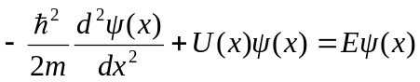
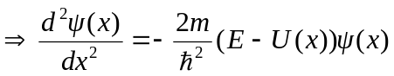
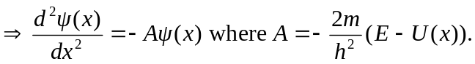
Note that if 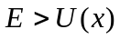 we are inside the well and 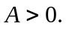 From the above equation, this implies 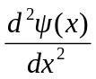 has the opposite sign of 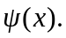
If 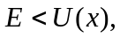 we are outside the well and 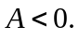 From the above equation, this implies 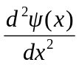 has the same sign as

